**THE ONLINE SHARING EXAMINATION BOARD**

**PRIMARY THREE EXAMS**

**SOCIAL STUDIES END TERM THREE 2023-SET 2**

Name: ______________________________________________________________________________

**SECTION ‘A’ (40 Marks)**

1. What do we call the symbol used on a map to show direction?

**____________________________________________________________________**

1. A representation of an object seen as drawn from above is called?

**____________________________________________________________________**

1. Draw a symbol for dam in the space below.



1. Name one district in Uganda surrounded by water.

**_____________________________________________________________________**

1. What do we call the social service Centre where people get medical care from?

____________________________________________________________________

1. Name any **one** physical feature.

**____________________________________________________________________**

1. Why do people keep their money in banks?

**________________________________________________________________________________________________________________________________________**

1. What is the capital city of Uganda?

____________________________________________________________________

1. Who is believed to have been the first Muganda?

**____________________________________________________________________**

1. How are markets important to people?

**________________________________________________________________________________________________________________________________________**

1. How is the sun useful to man?

**____________________________________________________________________**

1. From which direction does the sun rise?

**____________________________________________________________________**

1. Mention **one** activity done at school.

**____________________________________________________________________**

1. Which language is spoken by Basoga?

**____________________________________________________________________**

1. State **one** way of caring for domestic animals.

**____________________________________________________________________**

1. Mention **one** product got from sugarcane.

**____________________________________________________________________**

1. What name is given to the four major points of a compass?

**____________________________________________________________________**

1. Name any **one** type of family.

____________________________________________________________________

**____________________________________________________________________**

1. Name the lake in Uganda that provides us with salt.

**____________________________________________________________________**

1. Draw and name one item from clay.



1. What title is given to the king of Buganda?

**____________________________________________________________________**

1. Which animal is used for guarding people’s homes?

**____________________________________________________________________**

1. Give any **one** requirement needed to start a project.

**____________________________________________________________________**

1. Write **one** example of a custom.

**____________________________________________________________________**

1. How useful is a wall-clock in your classroom?

**____________________________________________________________________**

1. What is wind?

____________________________________________________________________

1. Draw and name any one domestic bird.



1. Write any **one** means of air transport.

**____________________________________________________________________**

1. Name the map symbol below.

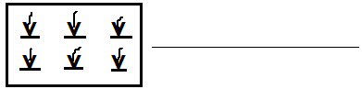

1. In which sub-county / division is your school located?

**____________________________________________________________________**

1. Name any **one** play material got from banana fibres.

**____________________________________________________________________**

1. Write O.C in full.

**____________________________________________________________________**

1. What do we call the sending and receiving of messages?

____________________________________________________________________

1. Give any **one** cause of accidents on roads.

**____________________________________________________________________**

1. Who was Kintu’s wife?

**____________________________________________________________________**

1. Draw a road symbol showing **‘No Parking’**



1. What name is given to a person who teaches children at school?

**____________________________________________________________________**

1. What is the commonest type of transport used in Uganda?

**____________________________________________________________________**

1. Name the instrument below.

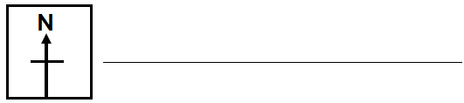

1. Write B.O.U in full**.**

**____________________________________________________________________**

**SECTION ‘B’ (60 Marks)**

1. a) Name these road signs.

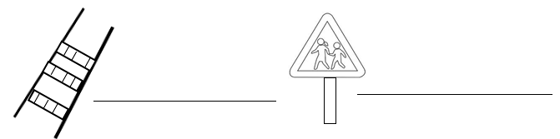

b) How are road signs important on roads?

**_______________________________________________________________**

**____**___________________________________________________________

c) Give any **one** danger of road accidents.

_______________________________________________________________

_______________________________________________________________

1. a) What are legends?

______________________________________________________________________________________________________________________________

b) Name any **one** example of a legend.

**___________________________________________________________________**

c) Name Nambi’s bad brother.

__________________________________________________________________

1. a) What is weather?

______________________________________________________________________________________________________________________________

b) Name **four** elements of weather.

1. _______________________________________________________________
2. _______________________________________________________________
3. _______________________________________________________________
4. _______________________________________________________________
5. Give **one** product got from each of the following crops.
6. cotton : _______**____________________________________**
7. tobacco : _____________**______________________________**
8. sisal : ___________________________________________
9. sugarcane : ___________________________________________
10. Match the items in group **‘A’** with those in group **‘B’**.

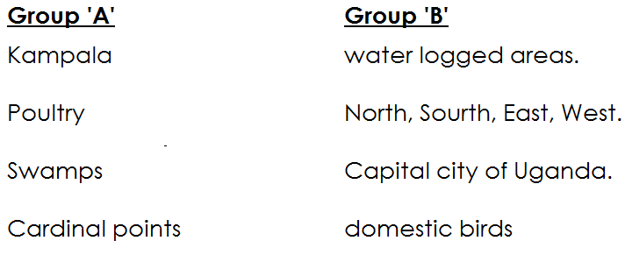

1. Kampala : ______________________________________
2. Poultry : ______________________________________
3. Swamps : ______________________________________
4. Cardinal points : ______________________________________
5. a) Who is a child?

**__________________________________________________________________**

**__________________________________________________________________**

b) Give any **two** roles of a child at home.

i) **_____________________________________________________________________**

ii) **_____________________________________________________________________**

c) Write any **one** form of child abuse.

____________________________________________________________________

1. Name the place where pupils go to acquire knowledge and skills.

______________________________________________________________________

(b) Mention any **three** symbols of a school.

(i) _______________________________________________________________

(ii) _______________________________________________________________

1. a) Which term is given to mean the four main points of a compass?

**_________________________________________________________________**

b) Give any **two** main points of a compass.

(i) **__________________________________________________________**

(ii) __________________________________________________________

c) Name any **one** group of people who use a compass.

_______________________________________________________________

1. a) Name the largest lake in Uganda.

**____________________________________________________________________**

b) Give **two** uses of lakes in Uganda.

i) **________________________________________________________________**

ii) **________________________________________________________________**

c) Mention any one method used for catching fish.

________________________________________________________**_______**

**_______________________________________________________________**

1. (a) Write down any **two** people who maintain peace and security at

school.

1. _______________________________________________________________
2. _______________________________________________________________

b) Give any **two** weapons used by policemen to maintain peace ad

security.

1. ______________________________________________________________
2. ______________________________________________________________
3. Choose the best answer given in the box to complete the sentences.

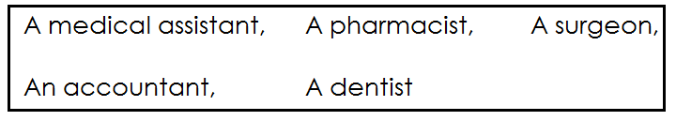

1. __________________________________ treats people’s teeth.
2. ____________________________________ prepares medicine.
3. ____________________________________ treats sick people.
4. _____________________________________ operates patients.
5. Draw the maps of these objects.

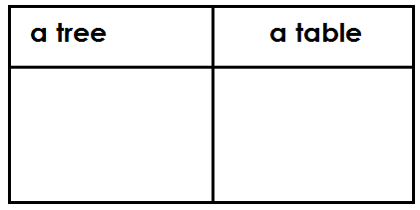

b) Give any **two** ways of locating places and directions.

(i) _______________________________________________________________

(ii) _______________________________________________________________

1. a) Define the term **‘culture’.**

**________________________________________________________________________________________________________________________________________**

b) Mention any **three** importance of culture.

i) **_____________________________________________________________________**

ii) **_____________________________________________________________________**

iii) ____________________________________________________________________

1. a) List **two** types of transport you know.
2. **_______________________________________________________________**
3. **_______________________________________________________________**

b) Which type of transport is commonly used by the people in Uganda

now?

__________________________________________________________________

c) What is the best type of transport for perishable goods over long

distances?

____________________________________________________________________

1. What are economic activities?

________________________________________________________________________________________________________________________________________

1. State any **two** economic activities.
2. **_____________________________________________________________**
3. _____________________________________________________________
4. Why do people carry out farming?

**______________________________________________________________________________________________________________________________**

***Good luck.***